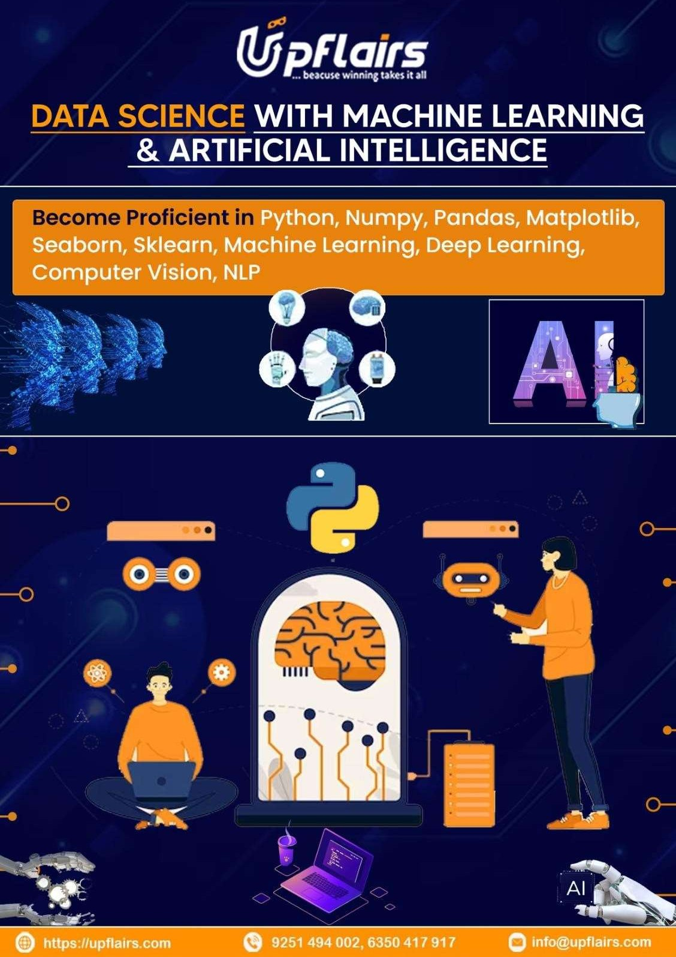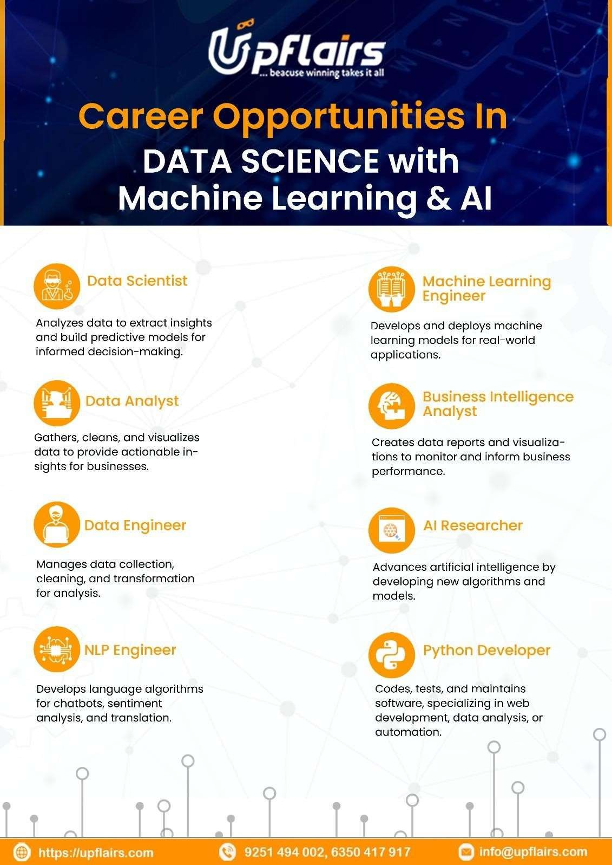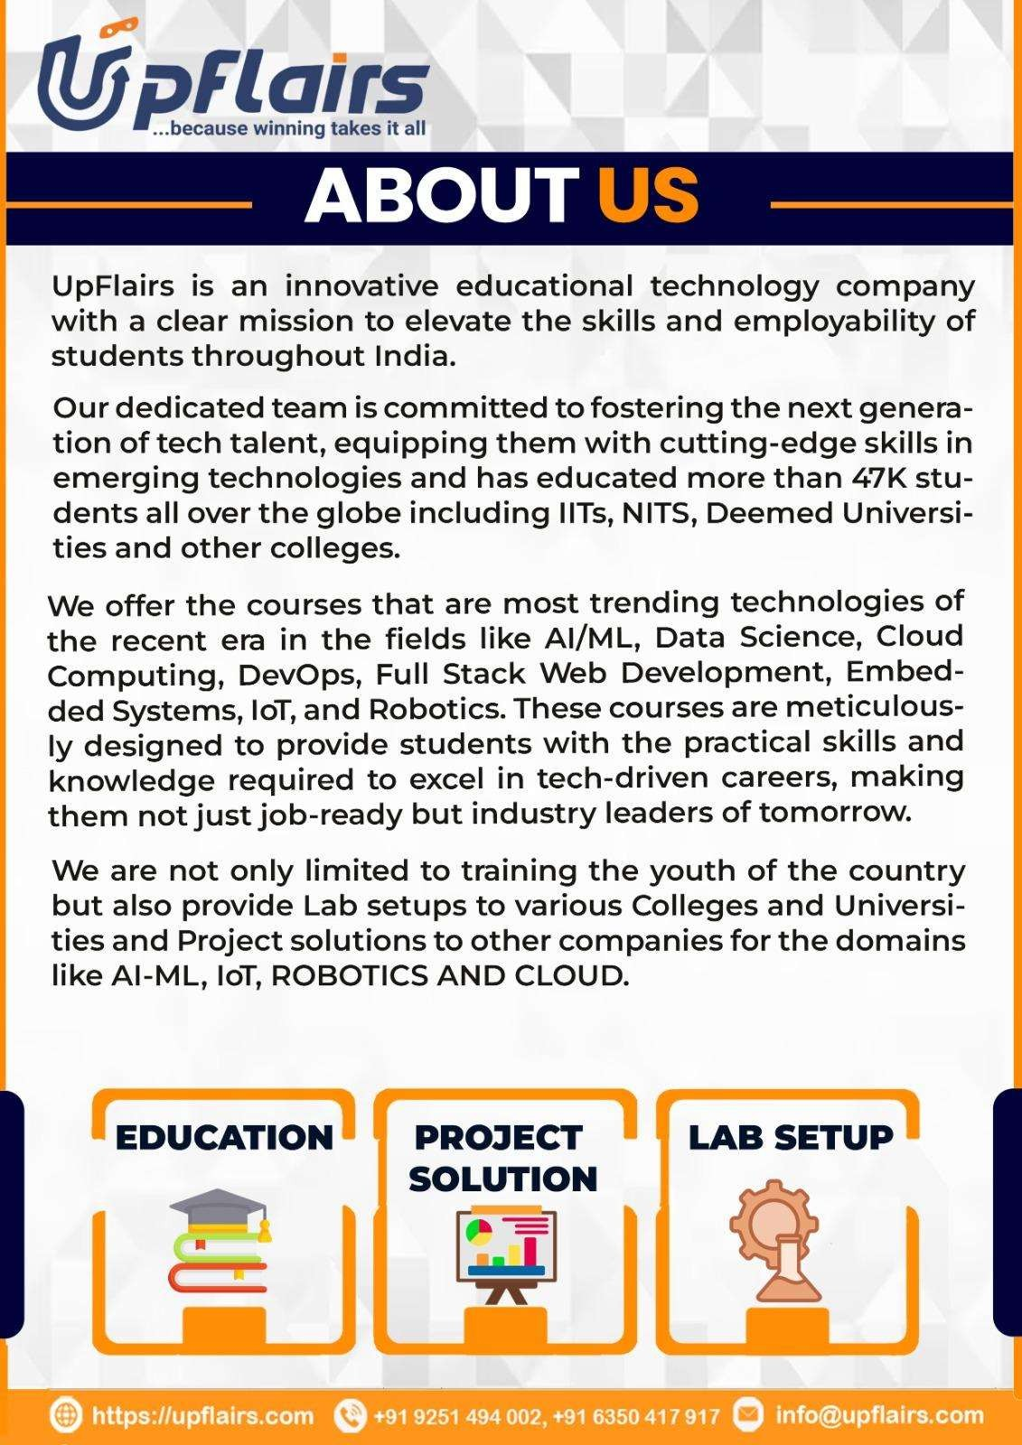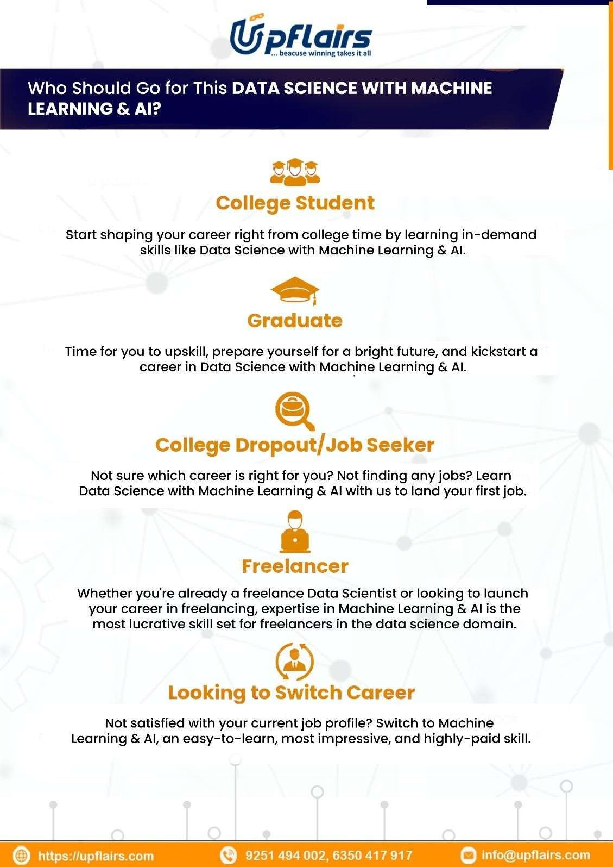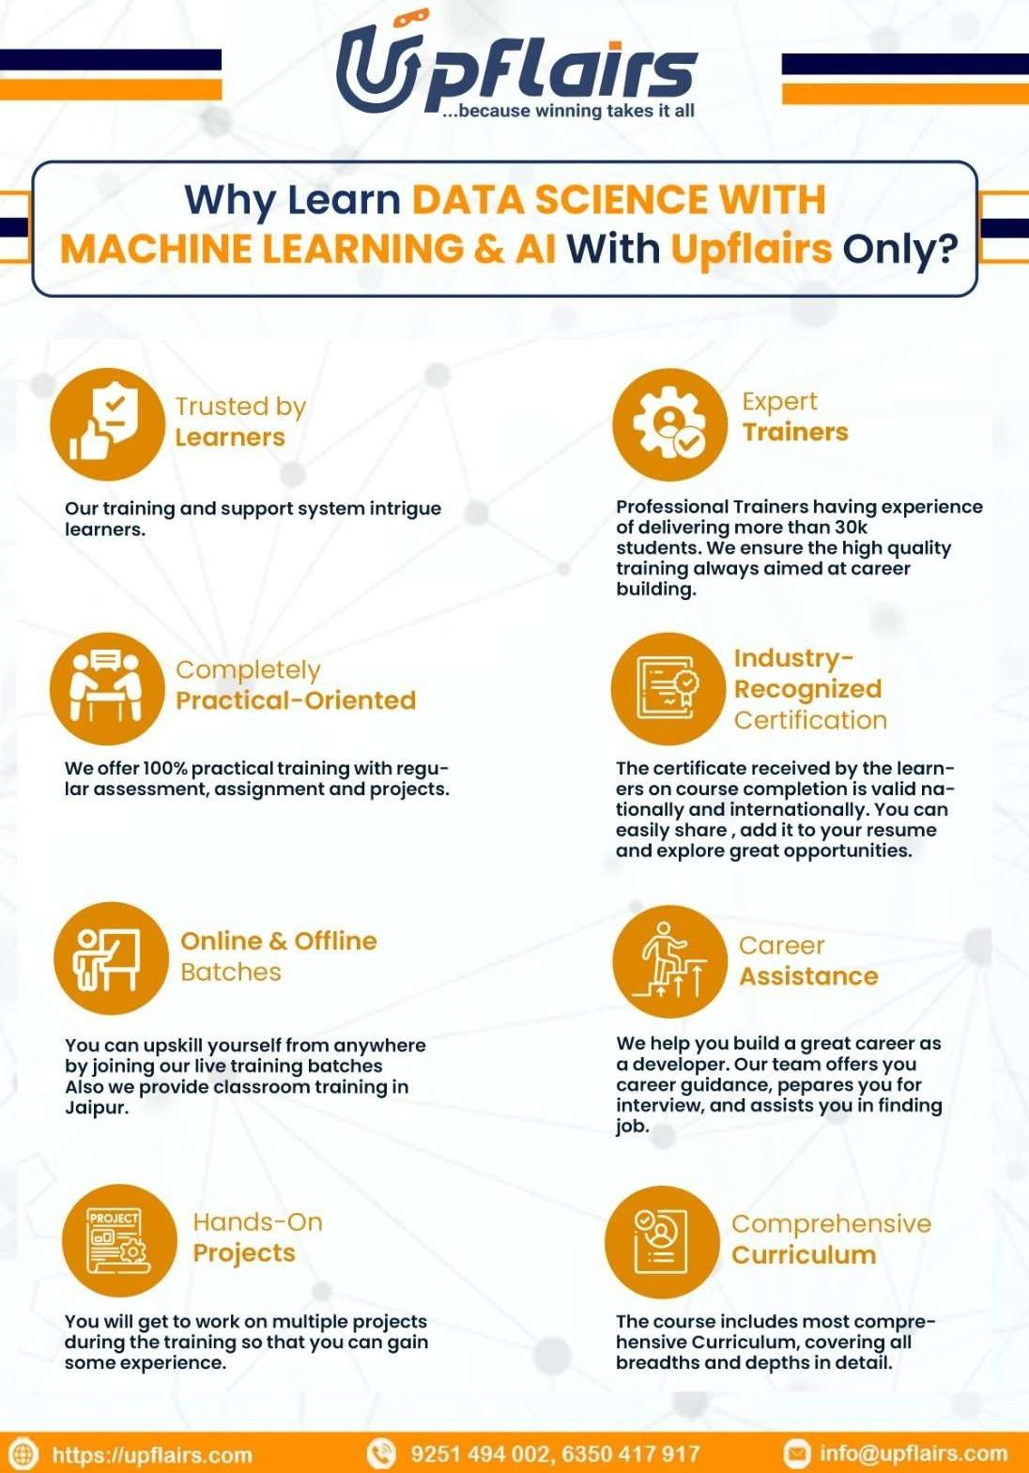

|  |  |  |
| --- | --- | --- |
| **DATA SCIENCE WITH MACHINE LEARNING** | | |
| **Duration – 6 Months (240 Hours)** | | |
| 1 | **Introduction (3 Hours)** | * Introduction with AI & Machine Learning * Data Science Vs Data Engineering Vs Data Analysis vs AI * Use of Data in the world of Data Science and machine learning * Connecting with Upflairs Community * Basic Linux/Windows Commands * Setting Up GITHUB & Google Colab/Kaggle |
| 2 | **Core Python Overview (30 Hours)** | * Python and Vs Code Download and Installation setup. * Python introduction, compiler vs interpreter, program execution * Keywords, Data Types, Operators and its types. * Conditional statements, Looping, exception Handling file handling * Comprehensions * Python User Defined Functions * Generators, iterators, decorators * Lambda Expressions * Python Modules: Usage and Installation * Creating own modules, and packages * Built In modules os, time, datetime, re, random, * The file handling in python * Dealing with Excel/CSV/txt files |
| 3 | **Oops python (11 Hour)** | * Class, object, instance, constructor, methods * Inheritance and its types * encapsulation * abstraction * polymorphism |
|  | **Mini Projects (4 Hours)** | ***Project 1:***   * ***ATM simulation project*** |
|  | **Capstone Project(2 Hours)** | ***Capstone Project 1:***   * ***CLI Based Chat Application*** |
| 4 | **Git & Github (3 hours)** | * What is GitHub? * Understanding repositories, commits, and branches. * Creating a GitHub account. * Creating a new repository. * Cloning a repository. * Making commits. * Pushing changes to GitHub. * Pulling changes from a repository. * Creating and switching branches. * Merging branches. * Resolving merge conflicts. * Forking a repository. * Creating pull requests. * Reviewing and merging pull requests. |

|  |  |  |
| --- | --- | --- |
| 5 | **Web frameworks Flask and streamlit (8 Hours)** | * Familiarity with HTML and CSS. * What is Flask? * Setting up a Flask environment. * Creating your first Flask app ("Hello, World!"). * Understanding routes and URLs. * Dynamic routes and URL parameters. * Using route decorators * Introduction to Jinja2 templating. * Rendering HTML templates. * Passing data from Flask to templates. * Creating and processing HTML forms. * Handling POST and GET requests. * Validating form data. * Structuring a Flask project. * Implementing basic CRUD operations. * Testing the application locally. * Introduction to SQL Alchemy or sqlite3 or MySQL. * Setting up a database connection. * Performing CRUD operations with SQL Alchemy or sqlite3 or MySQL. |
|  | **Assignment** | ***Assignment 1:***  ***Build portfolio website using flask*** |
| 7 | **Database (MYSQL + MongoDB)**  **(16 Hours)** | * Understanding the Database and DBMS, and RDBMS, * Understanding SQL and NoSQL databases. * Working with SQL database. * Writing CURD operations in database. * Write affective queries to filter out the data from the database. * perform various types of joins |
| **8** | **NumPy in Python (3 Hour)** | * What is NumPy? * Why NumPy is introduced on over the list? * Difference between NumPy and python list. * Creating NumPy array 1D, 2D, 3D Array. * Accessing item from array using indexing, * Data Manipulation in Array. * Searching and filtering in NumPy array. * Function to generate quick NumPy arrays like (zero, ones, Lin space, random) * Aggregation functions in NumPy. * Understand the difference between argmin and argmax. * Understand the difference between argsort and sort |

|  |  |  |
| --- | --- | --- |
| 9 | **Pandas (7 Hours)** | * What is pandas? * Overview of pandas * Installation of pandas * Data manipulation * Data transformation * Data cleaning * Missing value imputation * Redundant value handling. * Sorting, filtering * Understand about Series and Dataframe * Series: Creating, Indexing, and Basic Operations * DataFrame: Creating, Indexing, and Basic Operations * DataFrame vs. Series: Differences and Use Cases * Reading and Writing CSV, Excel, JSON, and other file formats * Functions in pandas (head(), tail(), info(), describe(),isnull(), dropna(), fillna(),loc[], iloc[],sort_values(),   sort_index(),groupby(),agg(),concat(), apply(),map(),merge(),lambda |
| 10 | **Data Visualization (6 Hours)** | * Data is Beautiful…!!! * Visualization Libraries in Python * MATPLOTLIB PYPLOT: line, scatter, pie, box, area etc * Decorating the plots using Matplotlib (labels, colors, markers, legend, grids, figure sizes etc) * The Subplots and axes in matplotlib; Showing Images * Pandas Visualization: Basic Plots * bar, barh, hist, box, kde, density, area, scatter, pie plots * Plotting with Missing Data * Easy and advanced Data Visualization from Seaborn |
|  | **Mini Project (3 Hours)** | ***Project 3 :***   * ***“End to End Data Analytics project on real world dataset”*** |

|  |  |  |
| --- | --- | --- |
| 12 | **Machine Learning Supervised (20 Hours)** | * Understanding the concept of Machine Learning * Types of Learning and their sub-categories * Linear Regression, Polynomial Regression * Regression model evaluation metrics. * L1 & L2 Regularization * Logistic Regression * Performance metrics (model evaluation techniques) * Support Vector Machines (SVM) * Kernel Nearest Neighbors (KNN) * Decision Trees Classifier * Hyper parameter Turning. * Bagging:- Random Forest Classifier * Boosting:- Ada Boost,Xgboost * Naive Bayes with Bayes theorem |
|  | **Mini Project (15 Hours)** | ***Project 4 :***   * ***Laptop price prediction*** * ***Old bike price prediction*** * ***Disease prediction*** |
|  | ***Assignment*** | ***Assignment 2:***  ***Bangalore house price prediction Insurance premium prediction*** |
| 13 | **Machine Learning Unsupervised**  **(8 Hours)** | * K-means & K-means++ * Hierarchical clustering (agglomerative, Divisive) * DBSCAN (Density-Based Spatial Clustering of Applications with Noise) |
|  | **Mini Project (3 Hours)** | ***Project 5:***   * ***Customer Segmentation*** |
|  | **Capstone Project (5 Hours)** | ***Capstone Project 2:***   * ***Farmer Guider Ai app.*** |
| 14 | **ANArtificial Neural Network**  **(2.5 Hour)** | * Concept of Deep Learning & Neural Network * What is ANN? * The basic terminology – Layers, weights, biases, activation functions, losses, optimizers, learning rate * The Concept of Forward & Backward Propagation * Using Keras Library for ANN * Building and Compiling Sequential Neural Network Mode * ***Exercise*** |
| 14 | **Image Processing (6 Hours)** | * What is image processing? * Applications of image processing * Image Representation: Pixels and bit-depth, Grayscale vs. Color Images. * Introduction to OpenCV, PIL (Pillow) * Loading, displaying, and saving images. * Image attributes (size, shape, and data type) * Scaling, translation, rotation, and affine transformation. * Flipping, resizing, and cropping images. * RGB to Grayscale. * Concept of histograms. |

|  |  |  |
| --- | --- | --- |
| 15 | **Computer Vision with CNN**  **(10 Hours)** | * what is computer vision * real world use cases of computer vision. * Understanding CNN working process * Filters, activation function, pooling layers, * flatten layers, cnn architecture, image feature extraction, * CNN architecture implementation. * Image classification. * Transfer learning techniques * Object detection: Localization using yolo. |
|  | **Mini Project (10 Hours)** | ***Project 6 :***   * ***Dog cat image classification*** * ***MNIST Data Classification*** * ***Sign language detection Using Yolo*** * ***Facial Emotion Recognition*** |
|  | ***Assignment*** | ***Assignment 3:***  ***Leaf Disease detection yolo Flower image classification*** |
| 16 | **Natural Language Processing (4 Hours)** | * What is NLP? Linguistic to Natural Language! * NLTK in Python for Text Processing * Text to Speech and Speech to Text Modules in Python * Optical character recognition (OCR): Text recognition. * Generating Word Clouds |
|  | **Mini Project (10 Hours)** | * **Spam and Ham Classification** * **Resume Screening** |
| 17 | **Natural Language Processing with RNN**  **(12 Hours)** | * What is RNN * How RNN is different from ANN * Types of RNN * Text cleaning steps, stemming and lemmatization, tokenization, stop words, pos tagging. Bag of words, Tf-Idf, embedding layer. * The Concept of Long-Short-Term Memory (LSTM) * LSTM based Neural Networks for Future Prediction!! * GRU. |
| 18 | **Generative Ai (4 Hours)** | * What is Generative AI. * Real world application of Generative Ai. * Encoder and Decoder Based Architecture understanding. * What are LLM models? * How does the LLM model work? * Learn about the LLM model working process and generate the data. * Transformers Architecture understanding * BERT and GPT model architecture * Learning About **OpenAI** and **Ollama.** * How you can use OpenAI and Ollama models into your projects? * Generating API Keys to Integrate Models. |
| 19 | **Introduction To**  **Lang chain and its components** | * What is Lang Chain? * Use cases and real-world applications * Integrating External Data Sources (PDF, HTML,TEXT) * Transforming Data For the LLM * LLM model Embeddings * Storing Vectors into Vector Stores * Exploring More About Lang Chain (Lang Smith, LangGraph,LangServe) |

|  |  |  |
| --- | --- | --- |
|  | **Minor project (11 Hours)** | ***Project 7:***   * ***Medical RAG Application*** * ***Language translation using LCEL*** * ***MathsGPT – Text to Math Problem Solver*** * ***Codellama – Multilanguage Code Generator*** |
|  | **Capstone Project (8 hours)** | ***Capstone Project 3:***   * **Build AI Job finder application** * **Generative Ai based Chabot** |

